Resource Practices Branch
Resource Practices Branch

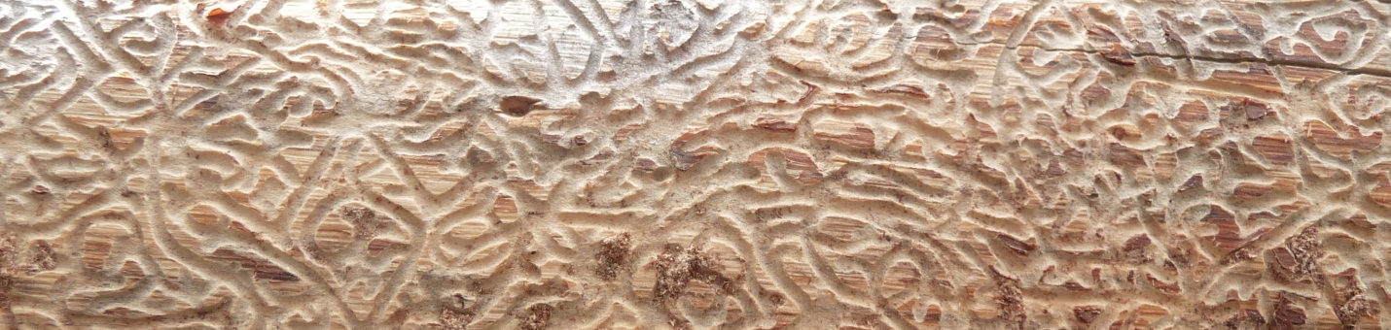
Welcome To The
Resource Practices Branch


Resource Practices Branch

